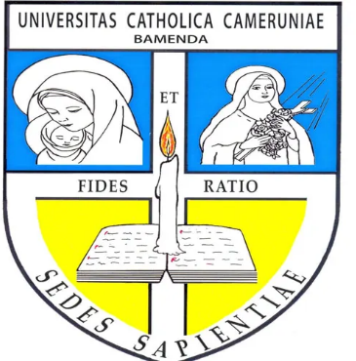
REPUBLIC OF CAMEROON
Peace – Work – Fatherland
MINISTRY OF HIGHER
EDUCATION

CATHOLIC UNIVERSITY OF CAMEROON, BAMENDA
(CATUC)
City of Wisdom
RÉPUBLIQUE DU CAMEROUN
Paix – Travail –Patrie
MINISTERE DE L’ENSEIGNMENT SUPERIEUR

CATHOLIC UNIVERSITY OF CAMEROON, BAMENDA
(CATUC)
City of Wisdom

{{SCHOO/FACULTY}}
DEPARTMENT: {{DEPARTMENT}}
COURSE: {{COURSE_TITLE}}
COURSE CODE: {{COURSE_CODE}}
LEVEL: {{LEVEL}}

{{ASSIGNMENT_TITLE}}

Presented By:
{{STUDENT_NAME}}
Matricule Number: {{Matricule Number}}

Course Instructor
{{LECTURER’S NAME}}
{{ACADEMIC YEAR}}

